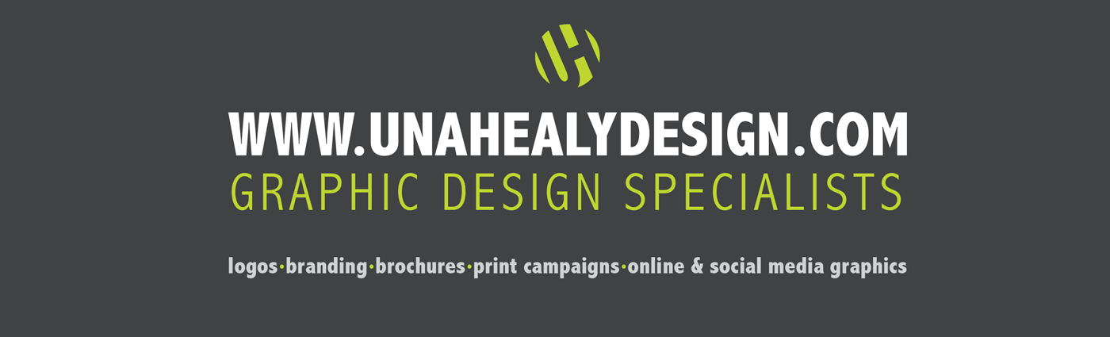

LOGO DESIGN QUESTIONNAIRE:

There are certain questions we like to ask a client prior to beginning the logo design process, to ensure good, clear communication. It may seem like a long list but it is helps us to know what you, our client, needs and expects from your finished logo/branding. It also helps to clarify your own vision for your business branding. Please take a little while to fill in this questionnaire:

YOUR BUSINESS

What is the name of your business?

Describe in one sentence your business/service

If you are not a new business start-up – what are the reasons you want a new logo?

What are your business short term, medium term and long term goals?

What do you want your new logo to achieve?

Who are your main competitors and how do you differ from them?

What do you like or dislike about your competitor’s branding?

Who are your potential clients?

Where will your business be publicised?

_______________________________________________________________

YOUR LOGO

Do you have a specific idea in mind for your logo?

Do you want to use existing brand colours or a particular range of
colours?

_______________________________________________________________

Are there any colors that you do not want to use?

_______________________________________________________________

Do you have a particular font you would like to use – or ones you definitely do not want to use?

_______________________________________________________________

What words should describe your logo?

What message or emotion do you want your logo to portray?

_______________________________________________________________

Does your logo have a tag line?

_______________________________________________________________

Is your tag line to appear with your logo on all of your branding?

_______________________________________________________________

Where will you logo be used?

_______________________________________________________________

What logos do you like and why?

THE PRACTICAL BITS!

When do you want your logo to be web/print-ready?

What is your Budget?

Would you like any additional design services alongside your new logo? (eg. business cards, letterheads & other stationery, social media icons/banners, advertising material etc.)

_______________________________________________________________

Any other comments?

_______________________________________________________________

